To develop a web site in Visual Basic (I am using 2005):
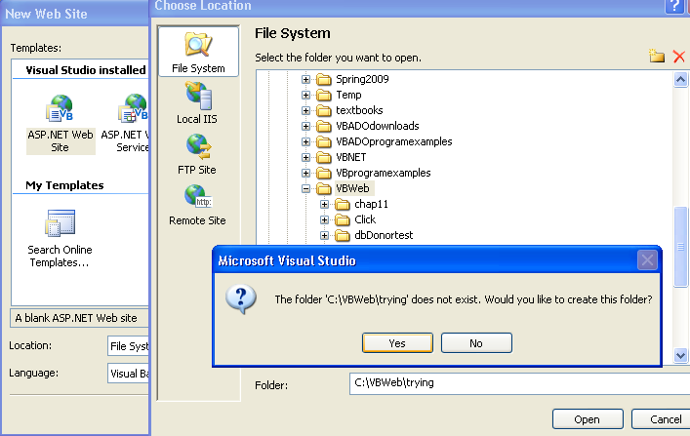
In VB, click on File/New Web Site and then click on ASP.NET Web Site and browse to save
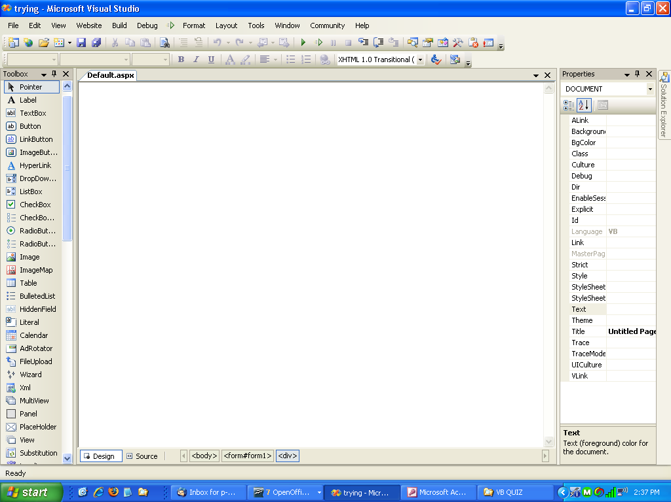

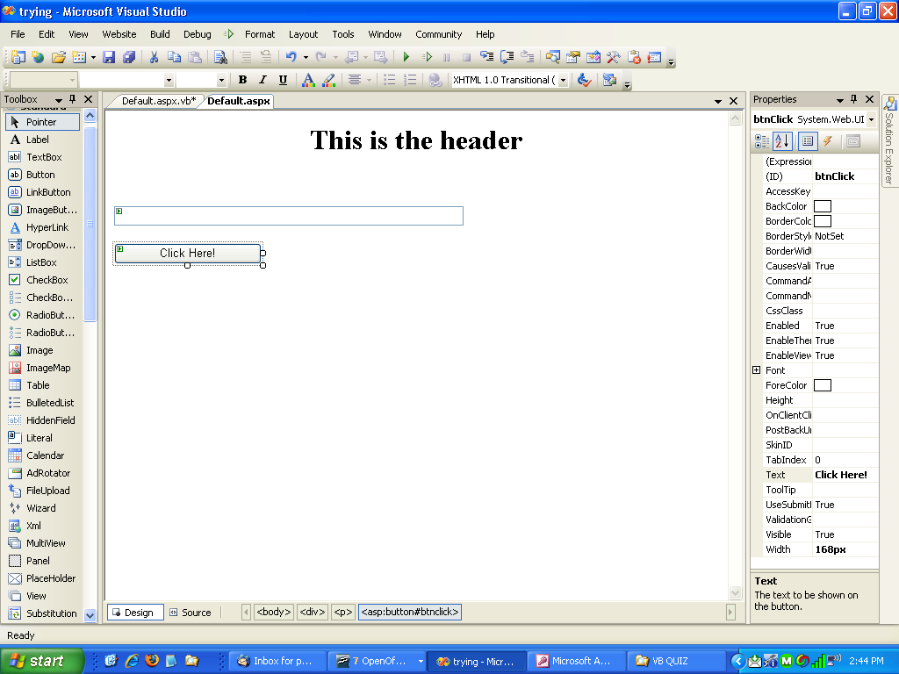
Partial Class _Default
Inherits System.Web.UI.Page

Protected Sub btnClick_Click(ByVal sender As Object, ByVal e As System.EventArgs) Handles btnClick.Click
txtGreeting.Text = "Hello and Welcome to Web Development in VB"
End Sub
End Class
Click on Cntl F5 to run or when the box comes up and asks about running without debugging, click Run without debugging.
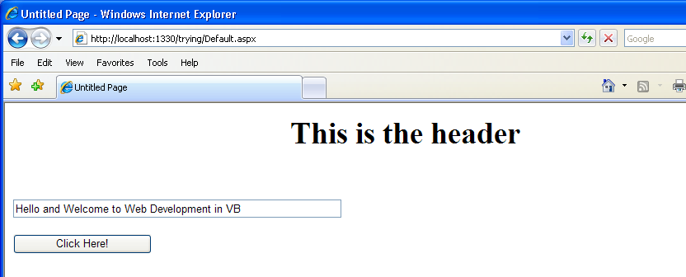

Now I want to upload to my Brinkster account:

First I log on and then I select classic file manager – you can use new file manager as well.
Now I can create a directory and then upload my code. I will call the new directory try. I can then move to that directory and upload using the browse feature.
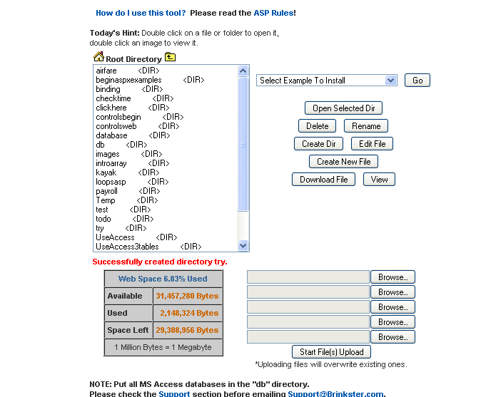
I need to upload the default.aspx and the default.aspx.vb. After they are uploaded, I can click default.aspx and then click on view to see them on the web site.
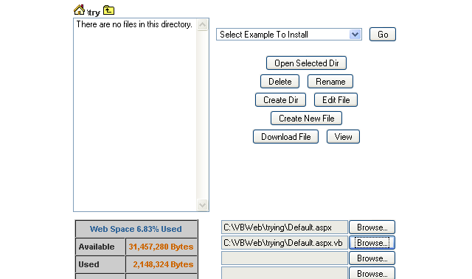

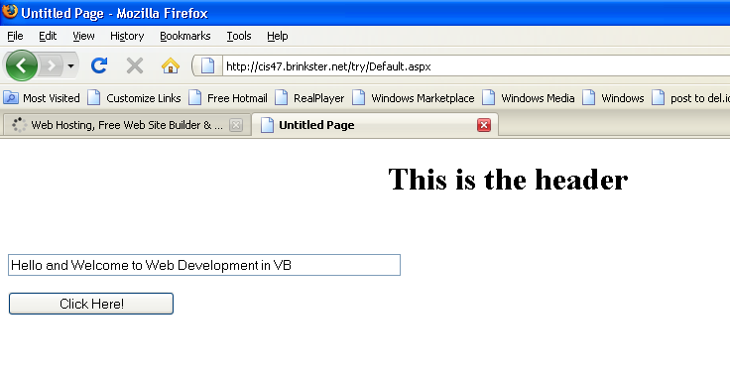
When I want to go back in to my project in VB I open Visual Basic on my computer. Then, I click on File/Open Web Site. I then select the folder and click on open. The project will come up in VB,

When I am working with databases, I should store my database in the db directory. I also need to change the setting. I can go into settings and copy the absolute root path that it shows.

Now I can go into the default.aspx of a program that uses a database.

<asp:AccessDataSource ID="DonorDataSource" runat="server" DataFile="root here\db\donor.mdb"

I want to take and put the absolute root path that I got from settings and put it into DataFile. Copy it exactly as you see it. Then go to the db and give the name of your data base. In this example, I have donor.mdb.

