Setting up to use Visual Basic in Excel:

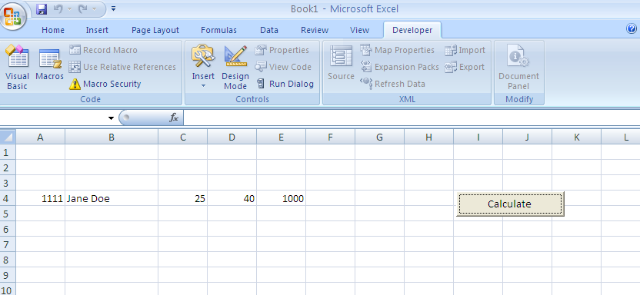

To set up the button, I went to Developer, went into Design Mode and clicked on Insert.
I then chose the ActiveX Controls command button and brought it down.

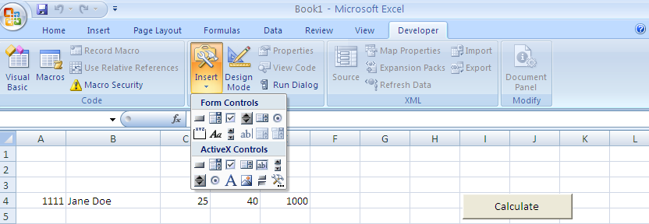

I then clicked on properties, gave it a name and the caption I wanted on the box.

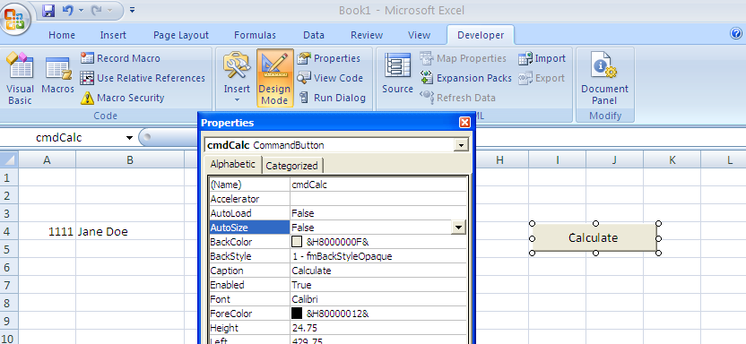

Now I double clicked on the button to bring up the code, or I could use View Code.

Note that this is a click event. When I want to refer to cells, I refer to them giving the row and column in numbers.
Private Sub cmdCalc_Click()
Sheet1.Cells(4, 5) = Sheet1.Cells(4, 3) * Sheet1.Cells(4, 4)
End Sub

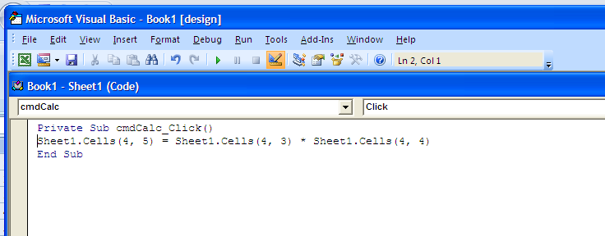

Note that I can name things, for example:

Private Sub cmdAnother_Click()
Dim theRow As Integer
Dim theColumn As Integer
theRow = 4
theColumn = 6
Sheet1.Cells(theRow, theColumn) = Sheet1.Cells(theRow, theColumn - 3) * Sheet1.Cells(theRow, theColumn - 2)
End Sub

Private Sub cmdCalc_Click()
Sheet1.Cells(4, 5) = Sheet1.Cells(4, 3) * Sheet1.Cells(4, 4)
End Sub

I then went in and named the sheet:

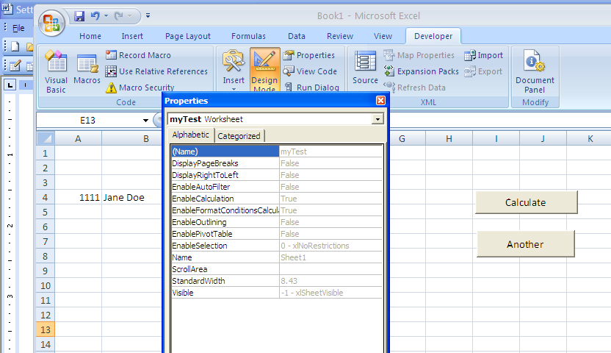

And then I changed the code:

Private Sub cmdAnother_Click()
Dim theRow As Integer
Dim theColumn As Integer
theRow = 4
theColumn = 6
myTest.Cells(theRow, theColumn) = myTest.Cells(theRow, theColumn - 3) * myTest.Cells(theRow, theColumn - 2)

End Sub

