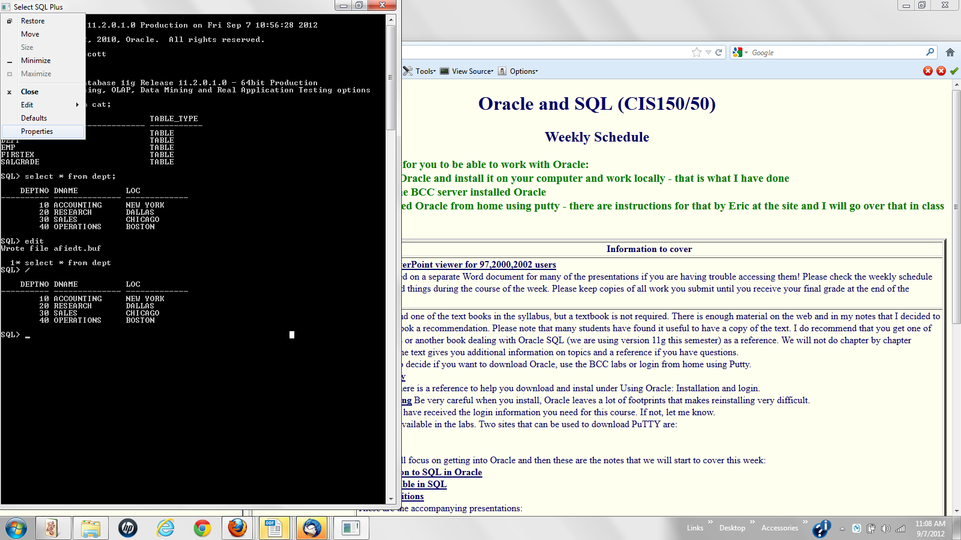
To be able to copy and paste, go to Defaults and check Quick Edit Mode. Then you can use Edit to copy and paste. Note that copy can also be done with Edit.
