Using local host to run the asp programs that I wrote.

First you need to install a local server.

I am using Visual Studio 2012 with Web Developer Express or Web Developer 2010 Express. Express versions are in different units so you need that. If you are using the full version the Web Developer is part of it.

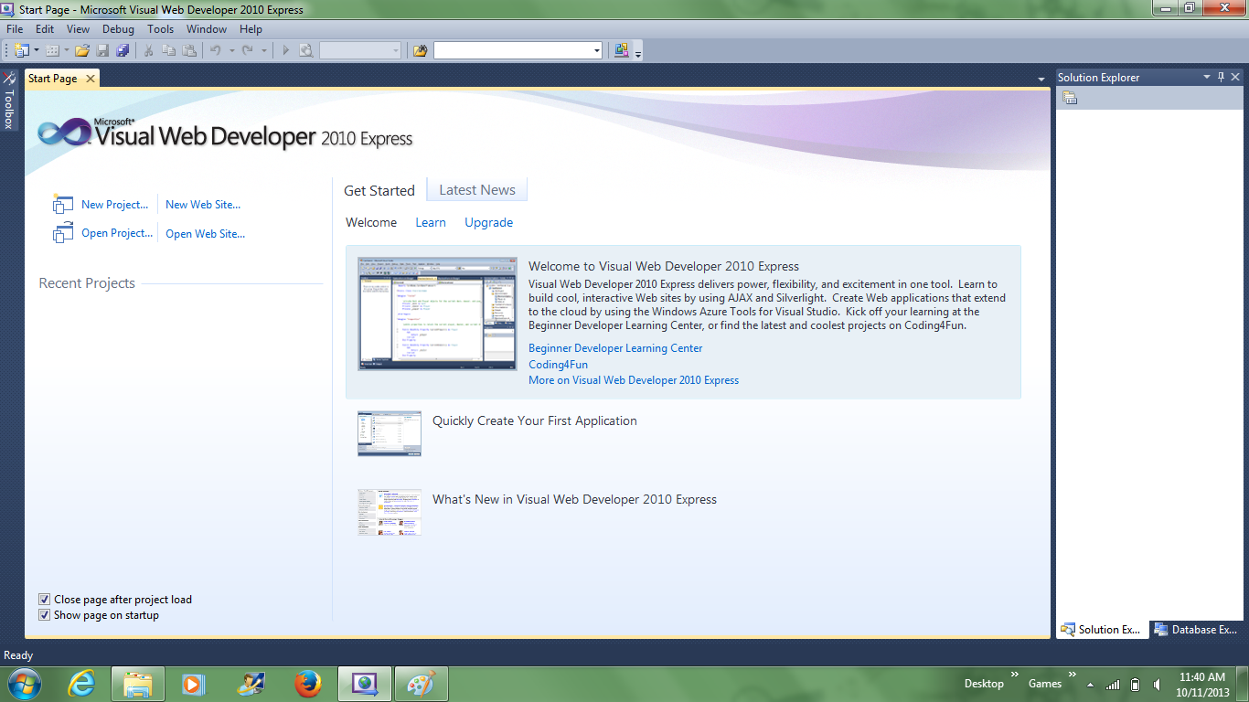

File/Open Web Site

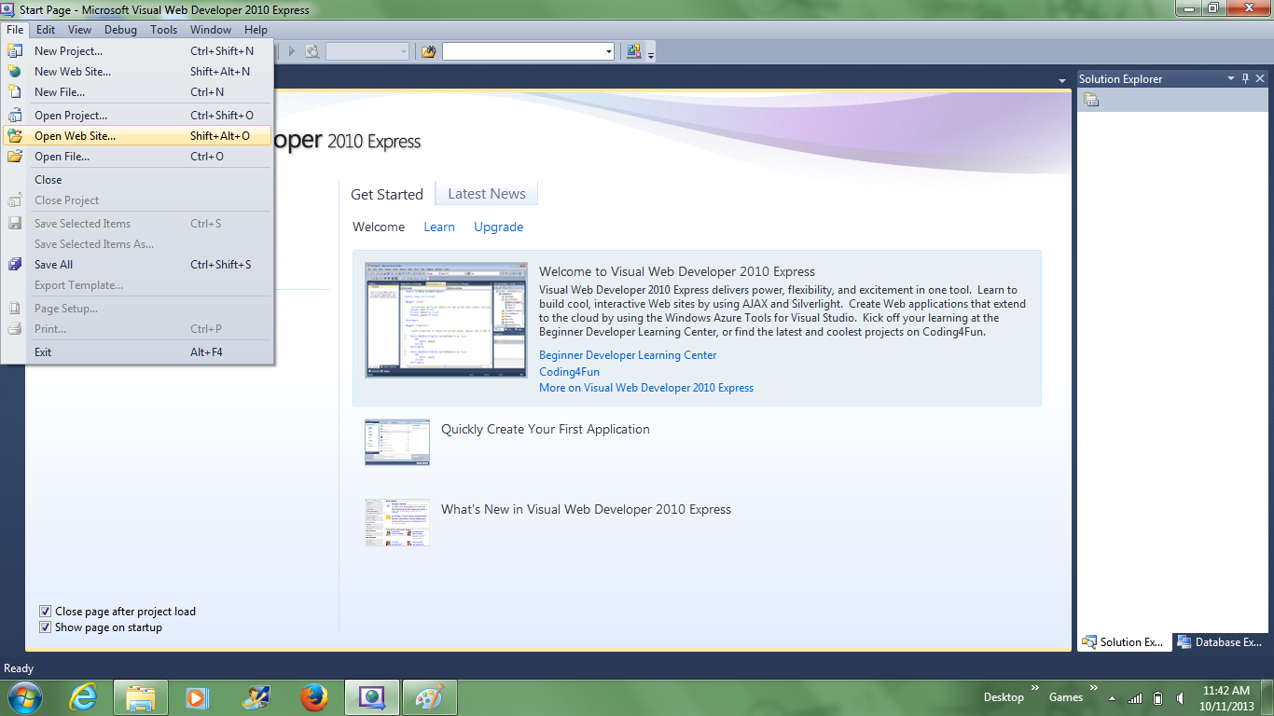

Now I have my asp files stored and I need to go to that folder.

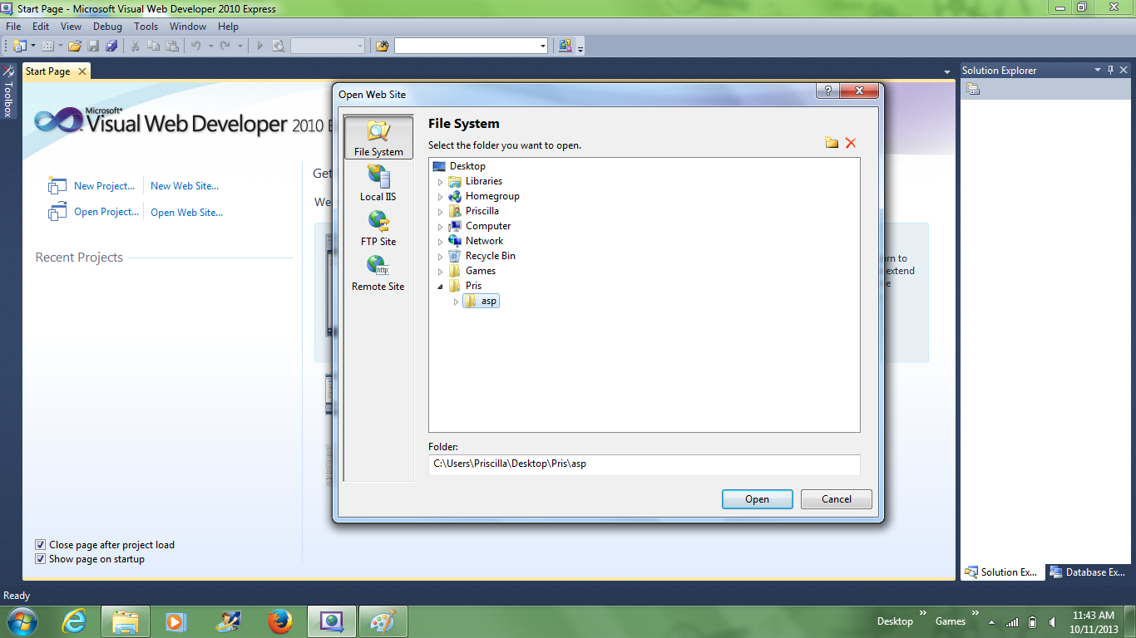
Click open on the asp director and it will show all of the files in that directory in Solution Explorer. If Web.config it will ask you if you want to create it so you can debug and you should say yes. It stores it in the directory.

Click on the one you want to see and the code will appear in a tab.



Click on the sideways triangle for debugging or you click F5 to get the same action. It will now run the asp code that you clicked on.

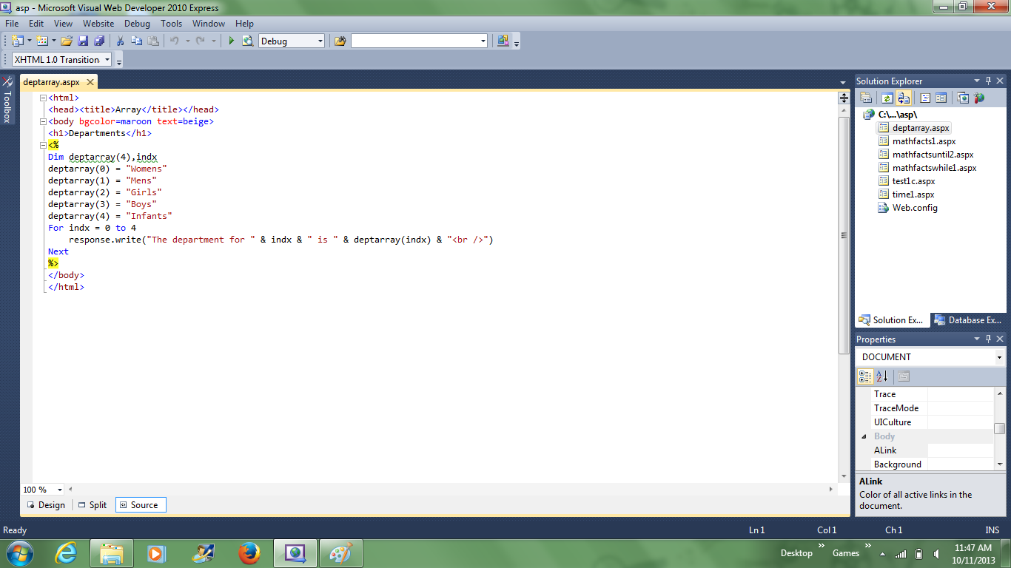
Output:

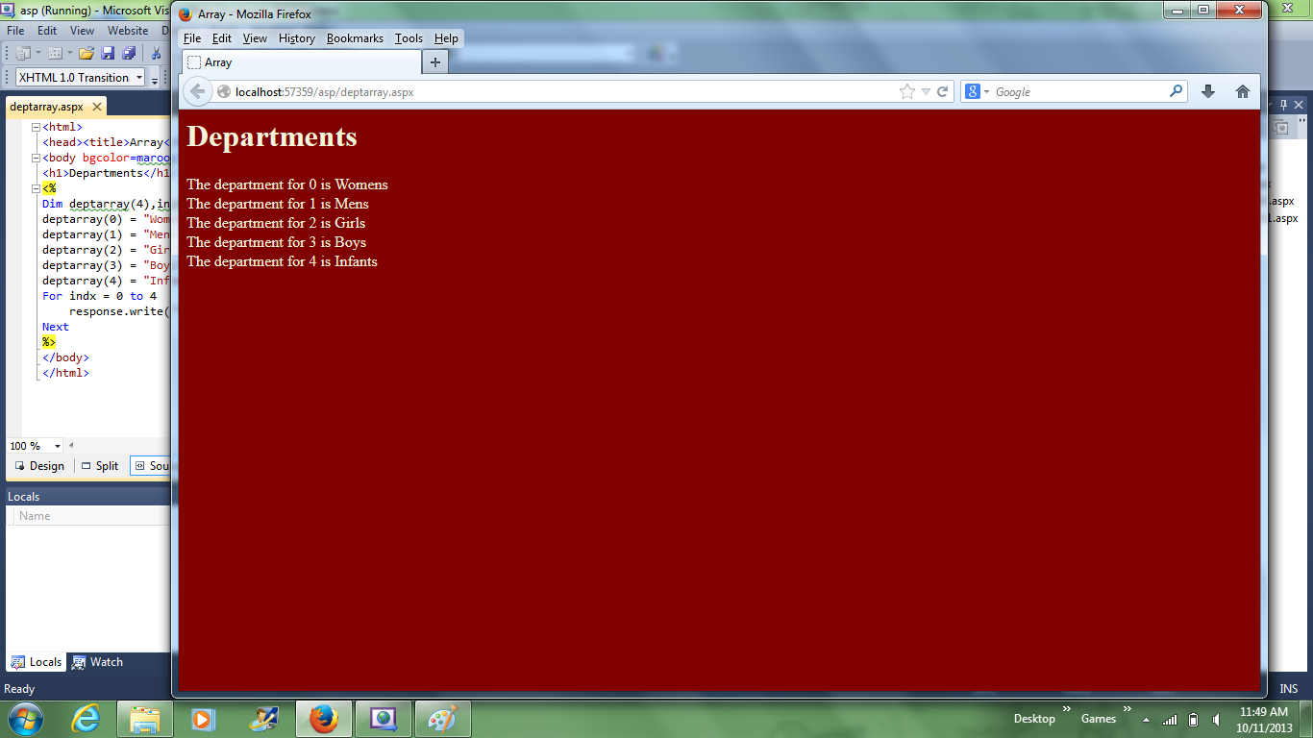
Now I have gone back and removed Web.config from the directory. This is the message you get. You can either choose to create the Web.config or run without it as the message says. Either way will run.

