I would like you to write this JavaScript page. I plan to go over it on Monday when our class meets next so I want you to pass in your best effort prior to that class.

Note that the medical plans subtract 50, 35 and 25 for the three possibilities. A is subtract 50, B is subtract 35 and C is subtract 25.
If you use salary:
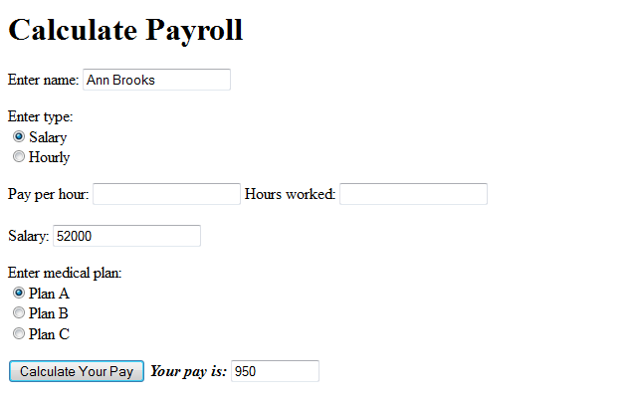
If you use hours:
