#1) I wrote a text file in notepad and then opened it so that you could see the hexadecimal translation of what I wrote. Look at the hexadecimal translation and then tell me what I wrote. Your answers should be in character (be aware of cases).

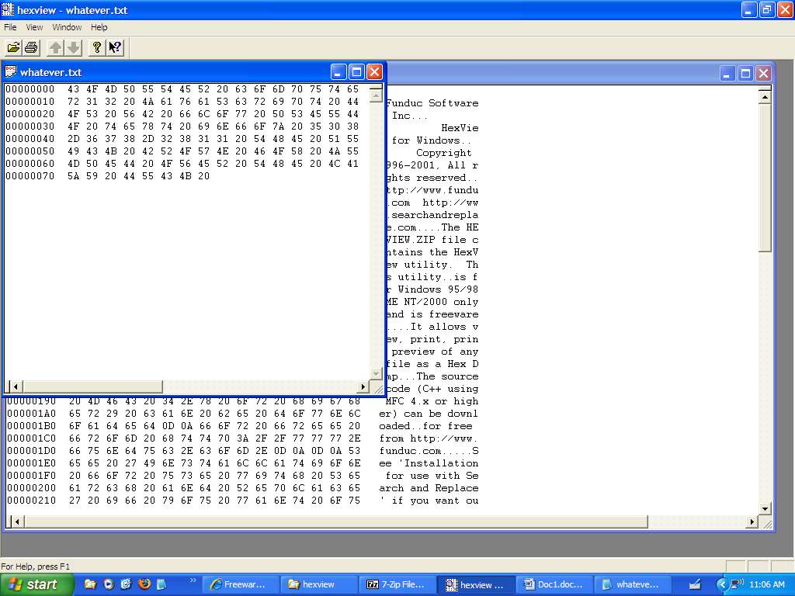

#2) Write the ASCII 8 bit code for the following hex (see above)

43 4F 4D 50

70 75 74 65

72 31 32

#3) What is the hexadecimal for the following ASCII 8 bit code:

01100101 01001110 01110010 01001111 01001100

#4) What are the characters (letters, numbers etc) for the following ASCII 8 bit code:

01100101 01001110 01110010 01001111 01001100

#5) Write the ASCII 8 bit code for the following:

CIS120
MAJOR
Quiz

